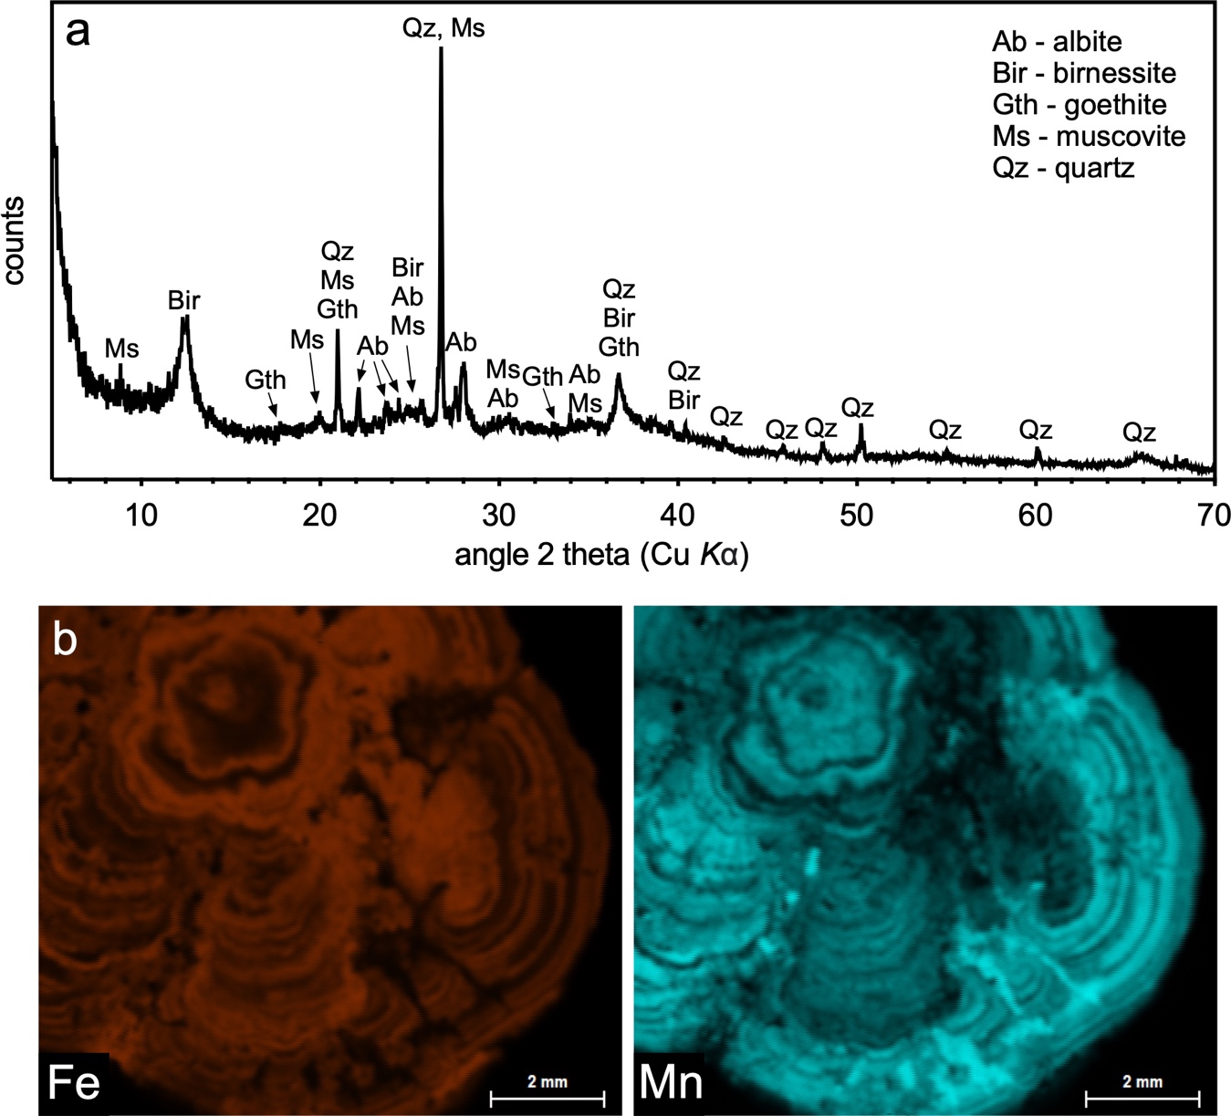

Supplementary Figure 1. Mineralogical composition of the Fe-Mn nodules used in the study. (a) X-ray diffraction pattern (XRD; PANalytical X’Pert Pro diffractometer); (b) Spatial distribution of Fe and Mn in the nodule obtained by micro X-ray fluorescence spectrometry (µ-XRF; Bruker M4 TORNADO).

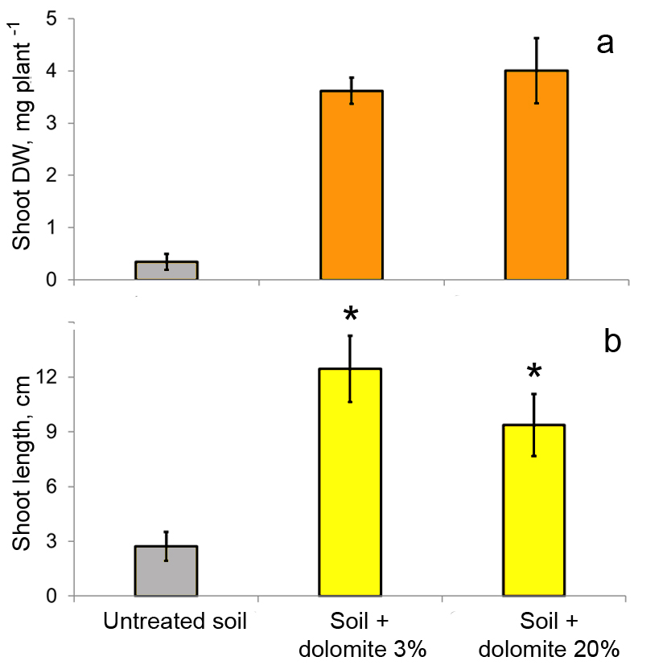
Supplementary Figure 2. Effect of different doses of dolomite (3% w/w and 20% w/w) on (a) shoot dry weight (DW) and (b) shoot length of ryegrass grown on Histosol (0-5 cm) from Apatity (Kola Peninsula, Russia) contaminated by the atmospheric emissions from a nickel-copper (Ni/Cu) smelter. Means and standard deviations are shown (n = 4). Untreated soil is also shown for comparison. Asterisks indicate a statistically significant difference between different doses of dolomite with respect to shoot length (p < 0.05). All-purpose fertilizer was added in all cases at a rate of 0.4 g fertilizer per 1 kg substrate.

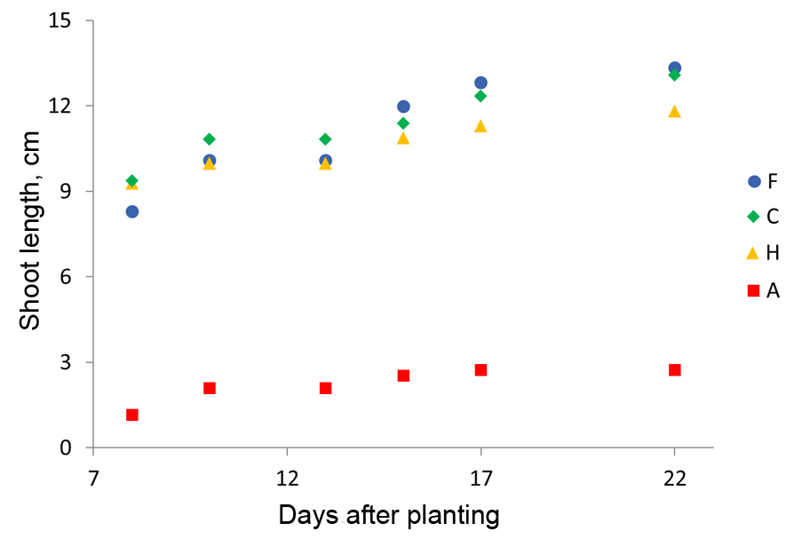
Supplementary Figure 3. Shoot length of Lolium perenne as a function of growth time in the soil under study. Results are shown for the following iron-based treatments in a biochar matrix: A: untreated soil; C: dolomite (3%) + ZVI nanoparticles/biochar composite (4%); F: dolomite (3%) + biochar (2%) + Fe-Mn-nodules (2%); H: dolomite (3%) + biochar (2%) + iron powder (2%). The remainder of the treatments are not shown to simplify the figure and improve clarity and understanding.

Supplementary Table 1. Effect of different doses of dolomite (3% w/w and 20% w/w) on the concentration of exchangeable fractions of metals in the soil under study.

Dolomite dose | Co, mg kg⁻¹ | Cu, mg kg⁻¹ | Mn, mg kg⁻¹ | Ni, mg kg⁻¹ | Zn, mg kg⁻¹
3% | 0.80±0.15 | 11 ± 1.0 | 9.3 ± 1.8 | 17 ± 2.9 | 0.60 ± 0.01
20% | 0.30 ± 0.05* | 12 ± 0.60 | 4.8 ± 1.1* | 6.7 ± 0.58* | 0.40 ± 0.12*
The concentrations of exchangeable Cd were below the detection limit. An asterisk indicates a statistically significant difference between dolomite doses.

Supplementary Table 2. Effect of different doses of dolomite (3% w/w and 20% w/w) on foliar metal concentrations of ryegrass grown on the soil under study. The values of pH (in 0.01 N KNO₃) were 5.8 and 7.2, respectively. Toxicity thresholds for foliar metal concentrations are shown for comparison.

Metal | Foliar concentration, mg kg⁻¹ |  | Toxicity threshold,  mg kg⁻¹ | Reference
 | Dolomite 3% | Dolomite 20%
Cd | 0.12 ± 0.04 | 0.13 ± 0.11 | 15 | Davis et al. (1978)
Co | 4.5 ± 0.78 | 5.4 ± 1.1 | 6.0 | Davis et al. (1978)
Cu | 29 ± 6.4 | 54 ±12 | 39 | Verdejo et al. (2015)
Mn | 129±32 | 413 ± 105 | >400 | Reuter and Robinson (1997)
Ni | 110 ± 18 | 62 ± 8.1 | 80 | Reuter and Robinson (1997)
Zn | 35 ± 9.7 | 17 ± 4.0 | 560 | Smilde (1981)

